Links for reference
 | https://developer.mozilla.org/en-US/docs/Web/HTML
 | https://html.spec.whatwg.org/multipage/
Git hub url of my Udemy trainer jonas | https://github.com/manideep-vv/Forked-html-css-course
Book dummies GIT hub repo links | https://github.com/paulmcfe/web-coding-and-dev-fd
Css websites | https://css-tricks.com/

As of now html 5.2 is latest even on 2024

Static website is a website which is same for every user, | Dynamic website is a website which changes for every user  Ex:- Udemy is a dynamic website- which looks differently for every user  For each user, courses recommendation is different based on his enrolments so Udemy is dynamic

HTML – hyper(links to other page using <a href> tags) text markup (u can bold or italize some elements means highlight) language
You always need to have fun while coding u should enjoy it
Any website u hit, we will get the html, css, and JavaScript files
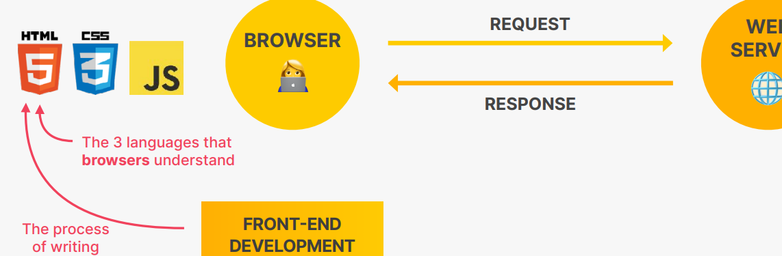

HTML | It is the actual data of the page – text, images, button
CSS | For styling
Js (this is the actual programming language of front end) | Add dynamic and interactive effects,  To load data from web server  To manipulate the content

basics codes

With head, title
- The <!DOCTYPE html> declaration defines that this document is an HTML5 document represents the document type, and helps browsers to display web pages correctly.
It must only appear once, at the top of the page (before any HTML tags).
- The <html> element is the root element of an HTML page
- The <head> --METADATA element contains meta information about the HTML page
- The <title> element specifies a title for the HTML page (which is shown in the browser's title bar or in the page's tab)
- The <body> DATA -element defines the document's body, and is a container for all the visible contents, such as headings, paragraphs, images, hyperlinks, tables, lists, etc.

We can write <script> tag inside a <body> this is called inline javascript  html file itself can load the java script file | <html lang="en">  <body>  <div id="app"></div>  <script type="module" src="/src/main.js"></script>  </body>  </html>

HTML element vs HTML tag
<h1> // here h1 is a tag, every tag will internally have some attributes like <input type =”text”> here input is tag, type is attribute of that tag
<h1> I am a paragraph </h1> this total tag+content == element
<input type=”checkbox”> // Here input is the tag and “type” is the attribute, “checkbox” is the attributes value
Most of the tags will have some attributes
<input type=”text” id=”one”> make sure id attribute value must be unique in the entire page
Block level elements  <div> | These elements will occupy the entire row  <h2> each h2 element will occupy the entire row
Inline elements – means these will not occupy entire single line  if u want to apply some style to some inline ele , then use <span>  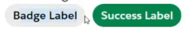  see these both buttons are coming on same line – each button is not occupying entire row  for this we cant use <div> if we use div then each button will be on diff row | All these elements will be in the same line  <i> abcd</i> <i> 123</i> <span>  Now both these elements will be in same line, hence these are called inline elements

Note: for every tag we can have an attribute called title
<p title=”t1”>
<input type=”text” title=”ad”>

<!DOCTYPE html> //This doctype is an indication to browser saying below is an html code  <html lang=”en”>  <head>  <meta charset="UTF-8" />  <title>Page Title</title>  </head>  <body>  <h1>My First Heading</h1>  <p>My first paragraph.</p>  <a href="https://www.w3schools.com">This is a link</a>  </body>  </html> | 2 types of elements are there  - Block elements- which will occupy entire line  Two <h2> tags can never be in same line- bec each h2 tag will occupy entire line  - Inline elements- all these elements will be in same line  Many <i> tags can be in same line  Ex:- <i id="i1">Modi should also take it seriously</i>  <i id="i2">Each state government also should ban plastic </i>  These two data will be in same line

2) HTML Attributes
<a href="https://www.w3schools.com">This is a link</a>
Here href is an attribute, attributes are used to provide additional info about HTML elements
The destination url must be specified in the href attribute,
<img src="w3schools.jpg" alt="W3Schools.com" width="104" height="142">
The source file (src), alternative text (alt), width, and height are provided as attributes:

3) all tags
self closing tags  <Route path="/classCompDemo" element={<ParentClsComp/>} />  for this since no closing tag, slash should come at last | separate closing tag – for this slash should come first  its like tag arrived late so keep slash at first  <Link to='/classCompDemo' className="sps">Class Comp life cycle hook demo</Link>

<br> these is no closing tag for br, it is called empty element, because we cant keep content inside that element
span vs div  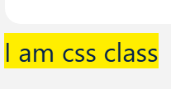  span will not occupy whole div , but div will occupy whole line | div  here see div occupied whole row  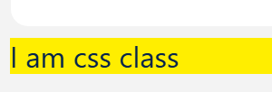
<p> | P means paragraph – these <p> <div> are just boxes to segregate elements- visually there will not be any change
<div> | This div (divide) tag is used to segregate or group some elements without any meaning
<h1> ….. <h6> | These are block elements , means these will take entire row
<a href= “www.google.com”>, , <p>
<b> // b means bold or to bring attention  <h4>vammov</h4>  <strong>vammov</strong> <br> //use only strong instead of bold not sure why?  <b>vammov</b> | To bold  All these 3 tags gives same output
<p><em>vammov</em></p> // em means emphasize to make it italic or bend  <p><i>vammov</i></p> // italic or idiomatic | Both tags are to make italic, means slightly bend  Result  vammov  vammov
like <input type =”color” >
<input type="text" placeholder="Search by title, director, or year..." />
placeholder attribute is the pre-defined text

<button disabled=true
to disable a button just add disabled attribute

The <label> tag in HTML is used to define a label for form elements like input fields, checkboxes, radio buttons, etc. It improves usability and accessibility.  🔹 Why use <label>?  - Makes forms easier to understand  - Improves accessibility (screen readers can read labels)  - Allows users to click the label to focus/select the input  🔹 Basic Syntax  <label for="inputId">Label Text</label>  <input type="text" id="inputId">  🔹 Two Ways to Use <label>  1. Using for attribute (most common)  - The for value must match the id of the input  <label for="username">Username:</label>  <input type="text" id="username">  👉 Clicking "Username" focuses the input box. | 2. Wrapping the input inside <label>  <label>  Email:  <input type="email">  </label>  👉 No need for for and id.  🔹 Example with Checkbox  <label for="agree">  <input type="checkbox" id="agree"> I agree to terms  </label>  👉 Clicking the text toggles the checkbox.  🔹 Key Points  - Always associate labels with inputs for better UX  - Helps screen readers identify form controls  - Makes clickable area larger (important for mobile users)

// super script and sub script – this is also block elements  <p>E=mc <sup>2</sup></p>  <p>H <sub>2</sub> o</p>  This sub, sup elements are inline elements, just to bold and al | Result  E=mc ²  H ₂ o
Ordered Vs. un-ordered lists  Ordered = will contain numbers  Un ordered will not contain number it just will have bullet points | // Here li means list item Ol – ordered list Ul – un ordered list <h2>Languages Lists</h2> <ol> <li>python</li> <li>.Net</li> <li>c++</li> <li>Java <ul> <li>Core java </li> <li>Spring</li> <li>Hibernate</li> </ul> </li> </ol> <h2>Foods list</h2> <ul> <li>Millets</li> <li>Bull driven oil</li> </ul> Result Languages Lists - python - .Net - c++ - Java - Core java - Spring - Hibernate Foods list - Millets - Bull driven oil

Links  Anchor tags  - go to top of that page  <a href=”#” >go top</a> means it will goto the top  //Below means inside our website it is redirecting to folder “pages” and file named “contact.html”  This is called relative redirect , means same page  <a href="pages/contact.html">Contact us here</a> | This is also inline element  - This will append to current url  <li><a href="www.google.com">Goto google relative link</a></li>  //Redirect to another url  - This will directly redirect to google as we added https  <li><a href="https://www.google.com">direct google link</a></li>  - Redirect in next tab – instead of redirecting from current tab, it will redirect from next tab  <a id="start1" href="https://www.google.com" target="_blank">Go to google</a>  Target=_blank means it will redirect to another website in next tab, not from current tab, so that current tab will remains same

Anchor tags to navigate inside a html document  //we cant use class as, we must use id only  Below wont work  <a href=".start">goto start</a> //This says navigate to class named start  <p class="start"> Lorem I </p>  A element with that class is there, but still it wont navigate | When web page is big, if u want to navigate from first to last then use as below  So always use id to navigate instead of class selector  <a href="#end">Go to end</a> // instead of giving direct google url, we are giving like goto that id tag  <p id="start"> Lorem ipsum </p>  <p id="end"> Lorem </p>  <a href="#start">goto start</a>
<nav>  <nav> means navigation  We should keep all these navigation related tags like  anchor tags <a href=”#”> in the <nav> tag | <nav>  <a href="links.html"> Goto previous tab links page</a>  <a href="https://www.google.com"> Goto google </a>  </nav>  Instead of enclosing in <nav> even if u enclose in <div> no change in presentation, this is just for segregation or for uses purposes
Linking to same page elements | Assume if doc is so big if u want to redirect or goto same page elements  <h2 id="TreatDetails"> Acceptable Treats</h2> //These id must be unique  <a href="#TreatDetails"> Go to treat details </a> // Now if you see this anchor link goes to treat details link

Linking images  in HTML/React, img is a self-closing tag:  Linking Online images also possible  <img src="https://www.converse.in/media/wysiwyg/aug5_slices-04.png?auto=webp&format=png&quality=85"  alt="Khadar vali receiving the padmashri award"  />  object-fit: cover //for image we can apply this class  this style we can use of image, object-fit: cover is very commonly used so movie posters don't look stretched. | <img src="images/city.jpeg" alt="city skyline" height="500" width="547"/>  <img src="images/cake.avif" alt="slice of birthday cake" />  <img  src="https://images.unsplash.com/photo-1667481020991-31186b791c13?ixlib=rb-4.0.3&ixid=MnwxMjA3fDB8MHxwaG90by1wYWdlfHx8fGVufDB8fHx8&auto=format&fit=crop&w=2070&q=80"  alt="desert landscape"  />
<header>  <article> -- This is where we should place actual content  <aside> -- here we will write side content  <footer>  <article>  visually there will not be any change of using these tags, these are also just empty boxes like <div> <p>, these are for search engines | The purpose of creating these new elements is  screen reader software might allow users to ignore headers and footers and get straight to the content  similarly, search engines might focus on searching elements present in content in a <article>  instead of <header> <footer>  <header>  <nav>  <a href="https://www.google.com" target="_blank">  Dr.Khadar vali won padma shri award</a  >  </nav>  </header>  <article style="background-color: antiquewhite">  <div id="content">Khadar vali is the millet man of india</div>  <img src="images/padma.PNG" alt="Khadar vali receiving the padmashri award" />  <p style="border: 100cap">Trusted by</p>  </article>  <footer>  <div style="background-color: aquamarine">  He is the man born for healthy india  </div>  </footer>

Marquee  Here we are scrolling an image | To scroll in any direction from left to right, right to left  <marquee behavior="" direction="right">  <img  src="images/padma.PNG"  width="340"  height="340"  alt="Khadar vali receiving the padmashri award"  />

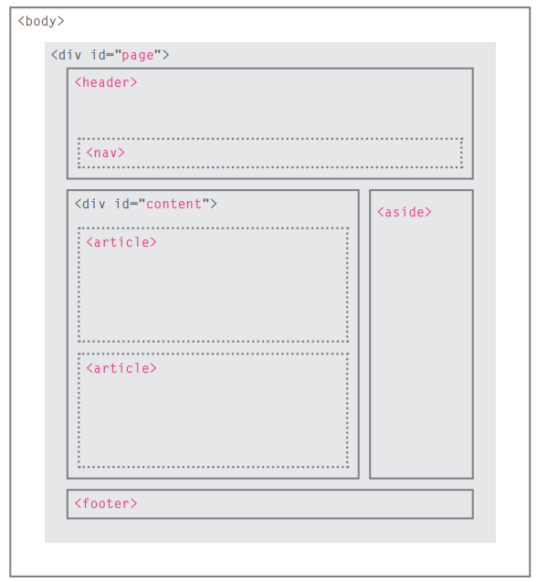

Basic tables
Tables can not only include text, but we can put images, links as well
You can edit and style the contents of a cell without disturbing the arrangement off the other table elements
By default all the code inside table will be inside <tbody> and we have to mention explicitly about <thead>
Basic table code |  | Row span and col span  Column span means spanning/extending that column across 2 columns | Standard HTML table
<table>  <tr>  <th>Movie Title </th>  <th>Release year</th>  <th>IMDB rating</th>  </tr>  <tr>  <td>Magadheera</td>  <td>2009</td>  <td>9/10</td>  </tr>  </table>  //result  Movie Title Release year IMDB rating  Magadheera 2009 9/10  // Here the problem is it won’t have borders and all | // its always best to include inside thead and tbody  <table>  <caption>Top movies in 2023</caption>  <thead>  <tr>  <th>Movie Title </th>  <th>Release year</th>  <th>IMDB rating</th>  </tr>  </thead>  <tbody>  <tr>  <td>Magadheera</td>  <td>2009</td>  <td>9/10</td>  </tr>  </tbody>  </table> | <table>  <caption>Top movies in 2023</caption>  <thead>  <tr>  <th>Movie Title </th>  <th>Release year</th>  <th>IMDB rating</th>  </tr>  </thead>  <tbody>  <tr>  <td>Magadheera</td>  <td>2009</td>  <td>9/10</td>  </tr>  <td colspan="2">Bahubali</td>  <td>10/10</td>  </tbody>  </table>  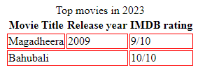  If u see this, the 2nd row is spanned or extended for 2 columns as there is no data | <table>  <caption>  It's Always Sunny Character Ages  </caption>  <thead>  <tr>  <th>Character</th>  <th>Age</th>  </tr>  </thead>  <tbody>  <tr>  <td>Frank</td>  <td>77</td>  </tr>  <tr>  <td>Deandra</td>  <td>46</td>  </tr>  <tr>  <td>Charlie</td>  <td>46</td>  </tr>  <tr>  <td>Mac</td>  <td>45</td>  </tr>  <tr>  <td>Dennis</td>  <td>47</td>  </tr>  </tbody>  <tfoot>  <tr>  <td>Average</td>  <td>52.2</td>  </tr>  </tfoot>  </table>

4) HTML forms
Label your input properly by giving the name of those ids
Below is the Worst way of labelling
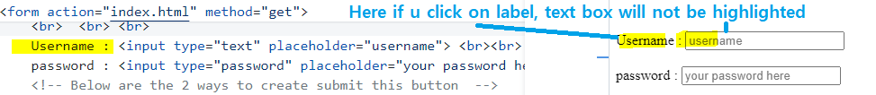
Best way
The main advantage is when u click on label, that corresponding box will be highlighted in yellow colour
<label for="u1">Username : </label>// Here in for attribute u should give value as the id value for the target tag
<input id="u1" type="text" placeholder="username"> <br><br>

sample events
onclick
onKeyUp
onChange | <input id="u1" type="text" onchange="someFunction "> <br><br>  here this function is executed when u change some text in the in the box

